Paper needs to analyze the case study below based on the questions and answers in the Template provided.

Case Study 1 Midsouth Chamber of Commerce (A): The Role of the Operating Manager in Information Systems
It was 7:30 P.M. on September 22, 2006, and Leon Lassiter, Vice President of Marketing with the Midsouth Chamber of Commerce (MSCC), was still in his office, reflecting on the day’s frustrations. Lassiter had met with four territory managers, his marketing support supervisor, and a number of other members of his staff. All were upset about their lack of access to the new computer system and the problems they were having using their old systems. Lassiter had assured them that the problems were being addressed. He stressed that patience was needed during the ongoing conversion to the new system.
Now, during his private moment, Lassiter was beginning to recognize the problems and complexities he faced with the system conversion. The work of his marketing staff, who were unable to access the new computer system to handle their accounts, had ground to a halt. Even worse, something had happened to the data in most of the workstations, which meant that conference registrations and other functions had to be done manually. These inconveniences, however, were minor compared to Lassiter’s uneasy feeling that there were problems with Midsouth’s whole approach to the management of information technology. Lassiter knew that time was of the essence and that he might have to step in and manage the conversion, even though he had no information technology background. He wondered what he should do next.
Background of the MSCC
In the early 1900s, economic development in the Midsouth area was highly dependent on transportation systems. As a result of legislative decisions, many communities in the Midsouth area could not gain access to reasonable transportation services, thus retarding business and economic development. With no one to represent their concerns to the state government, a group of powerful businesspeople formed the MSCC to lobby the legislature on the issue of transportation access.
The MSCC dealt with this single issue until the 1930s, when its charter was changed to include a broader range of issues affecting the business community, including state banking laws, transportation, industrial development, and business taxes. By the mid-1990s, the MSCC, under the new leadership of President Jack Wallingford, became an aggressive advocacy organization for the business community.
The broadening of MSCC’s role brought substantial change to the organization. In 1988 the MSCC had a staff of 14, a membership of 3,000 businesses and individuals, and an annual budget of $1,720,000. Over the years, the MSCC had been able to develop a reserve account of just over $1.5 million.
By 2000, the staff had grown to 24, the $1.5 million cash reserve had been drawn down to $250,000, and membership had dropped to 2,300, largely because of the loss of some major manufacturers in the region, the bursting of the Internet bubble, and the resulting economic slowdown. The reserve reduction, supported by the Board of Directors, had fueled considerable internal growth in terms of staff and capabilities. During this time, the MSCC also moved into larger offices and upgraded their workstations.
In the early 2000s the MSCC was considered the most powerful business advocacy organization in the Midsouth area and one of the most innovative chambers of commerce in terms of its approaches and techniques in dealing with problems facing the business community. The greatest problem facing the management of the MSCC at the time was the growing concern that its aggressive growth might have to be curtailed because it could no longer fund its annual operating budget.
Leon Lassiter
In mid-2000, Wallingford was faced with a serious dilemma. The MSCC was projecting a $330,000 deficit for the 2001 fiscal year. Wallingford realized he was going to have to reduce both the number of staff and the number of programs or find some way to grow revenue more aggressively in the organization. Wallingford asked his Vice President of Public Affairs and Operations, Ed Wilson, to find someone new to lead the sales and marketing function.
Leon Lassiter came to the MSCC in December 2000 with 12 years of experience in sales management and marketing with American Brands, where he had recently turned down a promotion to regional sales manager. The MSCC, he reasoned, offered more of an opportunity to have an impact than at American Brands. As Vice President of Marketing and Membership, Lassiter reported directly to Wallingford. After settling in to the organization, he initiated a thorough review of all programs, departments, and processes. He found that the marketing support functions were better coordinated and managed than the sales functions. Additionally, although the MSCC had purchased workstations for sales and marketing and had installed some custom software, the information system was quite limited in capability. Due to concerns over security, no staff member had access to all the data necessary to operate the marketing and sales activities of the MSCC. Each workstation was equipped to perform particular functions with the needed data resident on the workstation. With his analysis completed, Lassiter began to develop an entirely new sales and marketing process based on measurable goals, documented operating procedures, and regular training programs. He knew that eventually a new information system would have to be developed.
Information Technology Use at the MSCC
The Marketing and Sales Division
For a few years, Lassiter was able to operate his organization’s tasks with the existing set of individual workstations, all of which were connected to a print server. The marketing division’s primary information technology activities were to track the activity occurring in membership. Primary uses included:
• Developing the membership database
• Developing the prospective member database
• Making daily changes to both databases
• Generating a series of letters for personalized mail contact
• Generating prospect and member lists and labels by industry sector, firm size (sales, employment), zip code, mailing designator, and other criteria
• Processing call-record activity by the territory managers
• Tracking member activities and concerns through a comment field
• Creating audit trails for reviewing changes
• General word processing
EXHIBIT 1 MSCC Organizational Structure
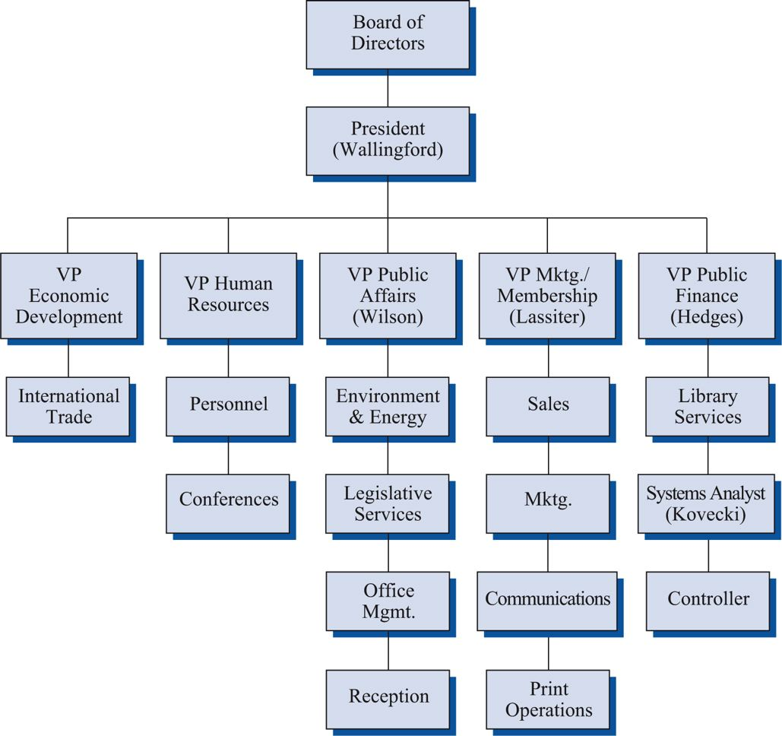
The marketing support area performed most of the computing tasks for the marketing division via their local workstations. They filled all requests for labels, lists, and changes from the sales and marketing staff. Requested changes to the member database sometimes backed up as much as two or three days. Lassiter felt this was unacceptable and hoped to achieve a two-hour turnaround on member-change activity.
Four territory managers, a marketing support supervisor, and five clerical people staffed the marketing division. The territory managers generated 75 to 80 call records per day that required database changes, letters, and invoice processing. These requests were processed by the clerical staff. In addition, the clerical staff processed commissions on membership sales, member cancellations, and general database maintenance. The clerical staff also prepared special-letter requests from the territory managers and performed all normal secretarial duties.
Operations Division
Ed Wilson managed the operations division. Eight managers and support staff worked in operations. This group was responsible for providing financial information and insuring accounting controls. The operations staff maintained:
• The general ledger system
• Fund balances
• Accrual accounting functions
• Payment history tracking
• Commission schedules
• Membership cancellation tracking
• Report generation
Wilson also planned to be able to track legislative bills from their introduction, through their demise in committee or chamber, their passage, or their veto by the governor. This information would be keyed into the system, updated as changes occurred, printed, and sent to selected staff members on a daily basis.
Human Resources Division
The human resources division, with two managers and two support staff, was responsible for developing a conference and seminar tracking and reporting mechanism that would also have the capability of printing out badges for conference or seminar attendees. The division also maintained personnel records.
Changing Times
By 2002, as a result of Lassiter’s marketing and sales reorganization and Wilson’s aggressive management of expenses, the MSCC was experiencing solid financial growth. While the two men were primarily responsible for the success, Wilson and Lassiter clashed on numerous occasions. Lassiter felt that much of the territory managers’ work and marketing support activities could be automated to provide the MSCC with a significant reduction in labor and allied costs. Lassiter believed that a fulltime systems analyst should be hired to meet the growing information needs of the MSCC. Wilson, on the other hand, was worried about the cost of the MSCC’s information systems. In the past, the MSCC had hired a consultant, Nolan Vassici, to make recommendations on hardware and software and to develop the custom software used by each division. Wilson felt that continuing to hire Vassici whenever additional or corrective work was needed was the best option. He did not want to increase the number of employees. Wilson knew that as a small, nonprofit agency, MSCC had limited funds for the expansion of computing capabilities. Adding a full-time systems analyst to the staff would make it significantly more difficult to respond to growing staff demands in other areas. Continuing the relationship with Vassici provided Wilson with the ability to specify exactly what Vassici worked on and what should be tabled until there was the time and budget for it.
Although Lassiter and Wilson continued to clash, Lassiter understood Wilson’s desire to control costs in light of the limited resources of the MSCC. Lassiter knew that the slowly growing computer sophistication of the staff would explode once the tap was fully opened. However, Lassiter felt that the demand could be dealt with effectively once the MSCC determined the extent of the staff’s needs.
In early 2003, Lassiter and Wilson joined forces on a concept by which the MSCC would offer a health insurance program to its members, now more than 4,500 businesses and individuals. Although the proposal was eventually rejected by the Board of Directors, Wilson and Lassiter, as a result of the study, recognized that there were many revenue-producing opportunities the MSCC could pursue that would require a much higher level of information systems use. Wilson soon hired a systems analyst to increase the MSCC’s capabilities.
Simon Kovecki, a young computer science graduate with no experience in a membership organization like the MSCC or with accounting software, joined the MSCC in June 2003 and spent his first three months on the job learning the organization and its computing systems. He worked exceptionally long hours as he struggled to understand software for which there was no documentation. Calls to Vassici for help were useless because his business had closed.
Through early 2004, Wilson continued to manage the computer systems and, with the help of Kovecki, upgraded the hardware in the workstations. With Kovecki’s constant attention, the software continued to work relatively well. In 2005 Wilson, with Kovecki’s assistance, developed an online legislative information system on a workstation that was considered state of the art in the chamber of commerce industry. With this application and the growth in members and types of computer applications, the MSCC senior management began to worry about the separation of systems for membership and marketing, finance, conferences, and other applications which required frequent data reentry.
With 2005 dues revenue approaching $2.8 million and approximately 4,750 member firms, the MSCC was among the largest statewide chambers of commerce in the country. The staff had swelled to 42 and the financial reserve was nearly $2.6 million. Although Lassiter felt some satisfaction with the MSCC’s growth and financial strength, he was bothered with the lack of forethought as to how the MSCC might develop a comprehensive plan to use information for the future. Wilson, too, recognized the value of information systems to an organization in the business of gathering, analyzing, and using information to affect legislative outcomes.
Catalyst for Change
By 2005, the MSCC had reached a point where some organizational changes had to occur. Wallingford, at the urging of the Board of Directors, assigned Lassiter the additional areas of communications, graphic arts, and printing operations. Controller duties were assigned to Harry Taska, and Jeff Hedges, the new Vice President of Public Finance, was assigned responsibility for computer operations. Wilson, nearing retirement, retained his public affairs activities and was asked to focus his efforts on developing an important public affairs project.
Just after the staff changes took place, Kovecki confided to Lassiter that he was disappointed by the changes in staff responsibility. He felt he should have been elevated to manager of information systems and given additional staff. Hedges, who had little computer background, was also in charge of research on various issues of interest to the members of the MSCC as well as oversight of the Controller’s function. Kovecki was concerned that Hedges would not have the time to manage the growing computer operations properly.
Lassiter shared Kovecki’s concern over the lack of top management attention to the information systems area. His concern led him to send out requests for information to a number of firms servicing the software needs of organizations like the MSCC. Primarily interested in sales and marketing software, he focused on software from Cameo, MEI Colorado Association of Commerce and Industry, Connecticut Business and Industry Association, TelePro 2000, and Data Link. Lassiter sent the information he received from these vendors to other senior managers but received little response. Wilson was involved in his new project, Taska was learning his new duties as Controller, and Hedges had little time to examine the computer activities.
In August 2005, Lassiter attended a national association meeting where a session on management software led to his discovery of a small software firm called UNITRAK. The company had developed a software suite that Lassiter was convinced would meet the MSCC’s needs. He based his assessment on the MSCC’s current and anticipated future needs for computing capability that had been developed by Kovecki in 2004. (See Exhibit 2.)
EXHIBIT 2 MSCC Information Systems Needs
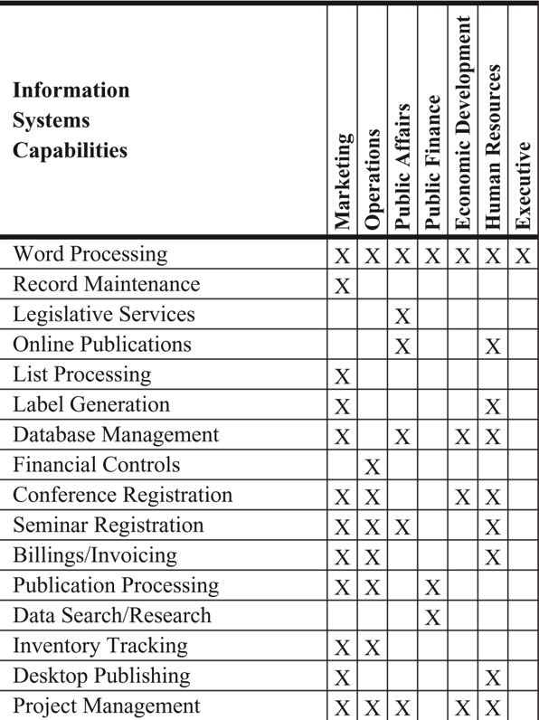
Planning the New Information Technology System
Lassiter had identified areas in UNITRAK where he felt this more powerful information system would allow the MSCC to be more efficient. These improvements would enable staff members to:
• Input special member information into a notes field (not then available)
• Generate telemarketing scripts that would allow “tree scripting” based on various sales objections (not then available)
• Utilize a statistical inquiry feature that would provide quantitative analysis of sales activity figures from all marketing activities (not attempted with the separate workstation systems)
In addition, the new information systems would allow territory managers to:
• Access their account information from their workstations rather than asking a staff member
• Develop letters and attachments from their workstations, using information in a central database rather than manually linking information contained in several separate databases
In a memo to the management group, Lassiter commented, “The UNITRAK system not only meets our needs now, but it is also powerful enough to provide the MSCC with the room to grow over the next 5 years.” The software also appeared to be user friendly, which Lassiter believed was the key to freeing up Kovecki’s time. Lassiter explained the software to Hedges, who wanted the current accounting software left intact but agreed that now was the time to move forward in finding a more powerful software solution for the MSCC’s problems. Hedges also agreed that other modules in the UNITRAK system could be activated at a later time.
In October 2005, Lassiter contacted Greg Ginder, President of the UNITRAK Software Corporation, and invited him to the MSCC for a demonstration of the system’s capabilities. Wilson observed about 30 minutes of the three-hour demonstration and told Lassiter, “I’ll support it if you want it. It will work for my project for public affairs.” Hedges agreed that the new system would free up Kovecki’s time and allow him to become more involved in planning and systems development. Kovecki’s comments were different. He remarked, “Yeah, the software has its strengths and weaknesses and it probably would save some of my time. But I don’t like the idea of staff having uncontrolled access to so much data. It’s not clear what they’ll do with it.”
The Proposal
Lassiter decided to move ahead quickly with a proposal to Wallingford and the Board of Directors. He developed simple flow charts that showed the hours it took to conduct certain activities, e.g., the staff time new member sales took with the current workstation arrangement, versus the time it would take with the new software. Lassiter knew that the Executive Committee of the Board would require considerable justification to approve an “off-budget” capital expenditure that would significantly reduce reserves. He had also done some calculations to show that if the new system performed as he hoped, each territory manager would be able to generate $150,000 in increased sales through increased contacts. Although Lassiter knew this goal was aggressive and very difficult to justify, he wanted to be able to demonstrate a less-than-six-month payback if challenged by a member of the Executive Committee.
Lassiter believed that UNITRAK would reduce the price of the software. The software was new, and UNITRAK had sold it to only one other statewide chamber of commerce organization, the Northern State Chamber of Commerce. Jeff Fritzly, Vice President of Marketing and Development of the NSCC, told Lassiter:
We looked at quite a few software packages as well as writing our own custom software, but our consultant chose the UNITRAK software. We purchased the software from UNITRAK and got a good discount on the needed new hardware. They have been very helpful and supportive of our needs.
A week before the Executive Committee meeting, Ginder and Lassiter agreed on a price for the software. Lassiter was pleased that the price was 30 percent less than Northern State had paid. With the help of Ginder and a member of the Executive Committee who headed the local branch office of a computer equipment manufacturer, Lassiter was also able to achieve an excellent discount on new server hardware. He felt this low cost was another justification for approval of the project. Lassiter also made it a point to meet with both Wilson and Hedges to keep them abreast of the negotiation and seek their advice. He felt that by increasing the level of communication with Hedges and Wilson, he would be able to gain their interest and support, which he felt was important to the success of the project.
When the Executive Committee of the Board met in November 2005, Lassiter explained that the MSCC had reached the limit of its current system design, and that an investment in a central server connected to networked workstations was needed to allow the MSCC to meet current and future opportunities for growth. During his presentation, Lassiter said:
While the MSCC has made significant and appropriate investments in the workstations necessary for the MSCC to increase its operational sophistication, we have reached the limit of these smaller machines. With the spectacular growth in revenue we’ve enjoyed over the last five years, our requirements and demands have increased dramatically. Without an immediate investment in increased capability, the MSCC’s continued growth and services will be in jeopardy.
In response to challenges from the Executive Committee regarding what the new system would mean to the bottom line and the MSCC’s reserves, Lassiter responded, “I believe we will see a 10–15 percent increase in sales and a 20 percent increase in staff productivity once the new system is operational.” With these assurances and a price that would consume only 10–15 percent of reserves, the members of the Executive Committee complimented Lassiter on his work and approved the purchase of the software.
Implementation
Greg Ginder of UNITRAK was ecstatic over the decision and promised unlimited support at no charge to install the new system. But Kovecki continued to express concern about staff members using the new capabilities of the system. He said:
I know that Lassiter expects this new software to be user friendly, but I’m uncomfortable with how strongly he feels about training the staff to use as many of the features as possible. He thinks that training the staff on whatever they want to learn will make the MSCC more effective, but I disagree. We would be opening Pandora’s box and we would lose control over what was going on. The last thing we need is for people to be getting into things they don’t need to be in.
By February 2006, Lassiter had heard nothing regarding the purchase of the new system. Kovecki told Lassiter that no one had approved the purchase order. Lassiter then questioned Hedges, who responded that he had heard nothing more and had been busy with research on issues of interest to the MSCC members. “Go ahead and purchase the software,” Hedges told Lassiter. “It’s your system anyway.” Although Lassiter tried to explain that it was not his responsibility to implement the purchase or conversion, he felt the project would not move forward without his purchasing the software. After signing the purchase order, Lassiter handed it to Kovecki and said, “You and Hedges are the project managers. I shouldn’t be involved at this point. It’s up to you guys to complete the project.”
Near the end of March, Lassiter asked Kovecki how the project was proceeding. Kovecki stated that the hardware had been delivered but that he was busy with a project of Wilson’s and didn’t have time to work on the new software. Lassiter went to Wilson to inquire about the anticipated length of the project Kovecki was working on, and Wilson indicated it should be finished by mid-April.
Although Lassiter felt uncomfortable about pushing Hedges and Kovecki, he was beginning to feel that he would have to use his influence to get things moving. Lassiter held a meeting with his staff, informing them that a new system had been purchased that would improve operations in several areas. Several staff members expressed concern that they had not been consulted or informed of the idea before its approval. Specific questions were asked regarding word processing, new member recruiting, and commission processing. Lassiter, anticipating that Kovecki had studied the documentation, asked Kovecki to answer the questions. Kovecki was unable to answer the questions and indicated he needed more time to study the documentation.
Lassiter set up an appointment with UNITRAK for training for Kovecki and himself. After a positive training visit, Lassiter asked Kovecki to spend half a day with him to set up a project flow chart and anticipate potential problems, but May and June passed with little forward progress on the conversion. Lassiter had told the Executive Committee that the project would be completed by the end of March 2006, yet little had been accomplished.
Upon Kovecki’s return from a two-week vacation at the end of June, Lassiter asked Wallingford to intervene and to strongly urge Hedges and Kovecki to complete the project. Lassiter stated:
It really bothered me that I had to go over Hedges’ head but we were coming up on the seventh month of what should have been an easy three-month project. It’s partly my fault because I didn’t establish teamwork up front, nor did I make clear early in the process the responsibilities of those participating.
The Final Phase
With Hedges’ agreement, Lassiter set up two days of staff training for the third week in August 2006. Kovecki had assured Lassiter that the system would be up by the last day of training so that the staff could immediately use the new system. Lassiter broke the training into major segments and had Kovecki set up training sites in two separate conference rooms for staff. UNITRAK sent a two-person team that would act as project managers and trainers.
The training went well with the exception of the conference and seminar segment of the software. The users brought up significant complaints that the new software servicing this area was not as functional and user friendly as the existing custom-written workstation software. Although Lassiter suspected that a large part of the problem was that the new software was just different, he asked UNITRAK to work with the users in adapting the UNITRAK software to better meet their needs. Ginder commented:
Because our software is relatively new to the marketplace, we are open to adjusting and changing certain aspects of the software without rewriting major portions. We feel we could learn a great deal from the MSCC which would make our software more marketable.
On the final day of training, Lassiter asked Kovecki to migrate and integrate the data in the current workstations to the new system. Kovecki told Lassiter that he was having a few problems and would conduct the migration after work, and it would be ready first thing in the morning. The next morning Kovecki, in responding to Lassiter’s query as to why the system was not up, said:
When I attempted the migration last night, less than 15 percent of the data rolled over into the proper assignments. With no documentation on the old software to refer to, it will probably take me a week to work out the bugs. In the meantime, the new system won’t work and some of the data in our current workstations seems to have been corrupted. I hope we can recover the latest backup, but some of the systems haven’t been backed up for more than three months.
Although one of the marketing division’s systems had been backed up recently, the rest of the MSCC’s workstations were basically inoperable. Requests for lists and labels for mailings could not be fulfilled. Word processing, payment and invoice posting, changes, list management, and so on were all inoperable or partially inoperable. UNITRAK was finding it difficult to help because Kovecki had forgotten to order a new telephone connection that would allow UNITRAK experts to have remote access to the system.
Lassiter was finding it very difficult to gain information from Kovecki on the progress and status of the system conversion. It seemed that Kovecki, frustrated with the problems he was having and irritated with the staff coming to him to ask for assistance, was going out of his way to avoid the staff. Lassiter said:
I explained to Kovecki that I wasn’t trying to grill him for information, but because the staff now considered me to be the project director, I needed information with which to make decisions affecting the work flow of the staff and determine what kind of help we could request from UNITRAK.
Although Lassiter knew that the staff felt he was responsible for the new system, he felt frustrated that there was little he could do in managing the conversion. Hedges remained disengaged from the project, and Kovecki did not report to Lassiter.
The Future
It was in this situation that Lassiter found himself as he sat in his office at 7:30 p.m. in late September of 2006. Kovecki had promised that the new system would be up on each of the last several Mondays. Each Monday brought disappointment and compounded frustration to the staff. Lassiter knew that the two days of training had been wasted because the staff had long forgotten how to use the new system. He also had heard that Kovecki was interviewing for a new job and was out of town on a regular basis. Something had to be done—but what?
(Brown 10)
Brown, Carol V., Daniel DeHayes, Jeffrey Hoffer, Wainright Martin, and William Perkins. Managing Information Technology for DeVry University, 7th Edition. Pearson Learning Solutions. VitalBook file.
The citation provided is a guideline. Please check each citation for accuracy before use.

